# ­ US_001: Classic email verifier

|  |  |
| --- | --- |
| Description | As a customer, I want to login with my credentials/create new account so I can securely access as a Classic email verifier and validate one email at a time |
| Assigned To | PO (Product Owner) |
| State | Ready / In Design / Done / In Review |
| Priority | High |
| Risk | High |

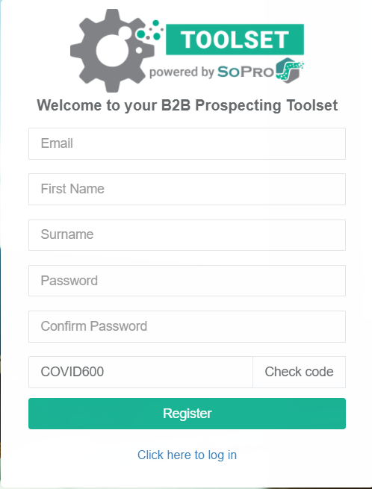

Acceptance Criteria:

|  |  |
| --- | --- |
| Email | General Email Regex (RFC 5322 Official Standard) |
| First Name | Input 256char |
| Surname | Input 256char |
| Password | Input masked |
| Confirm Password | Input masked |
| Check Code | Promo code |

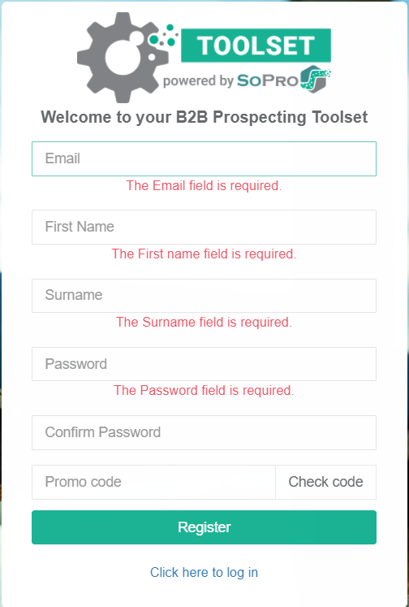

All fields are required data fields - error alert should be shown if user clicks on “Register” button without typing anything in the required fields.

Password entries will show the keystroke typed, and then after certain time (1s) the entered character is masked.

Green check mark next to 'Password' data field should be displayed that indicates to the user after typing password that the entry meets criteria

Red mark next to 'Password' data field should be displayed that indicates to the user after typing password that the entry does not meet criteria

After successful validation of all entered fields and on clicking “Register” button, a confirmation message for successful registration appears.

**\*NOTE: Unable to execute due to issues stated in the email.**

**Test Suite 1: Classic Email Verifier**

CEV_TC_1001: Login with invalid credentials

|  |  |  |
| --- | --- | --- |
| Description | This test script covers scenarios where a User attempts to login with invalid credentials | |
| Link to User Story | US_001: Classic email verifier | |
| Assigned To | **Andreja Misevski** | |
| State | Done | |
| Priority | High | |
| Risk | High | |
| Status | PASS | |
| Product | SoPro | |
| Type | Regression | |
| Automation | **Automated** | |
| Configuration | Windows 10 | |
| Prerequisites | Chrome Version 80.0.3987.116 (Official Build) (64-bit) | |
| Action | | **Expected Result** |
| Open Chrome and enter <https://toolset.sopro.io/email-verifier> | | User successfully navigates and lands on email-verifier page.  Enter mail Address input button is shown within the main content area and 2 buttons:   * Verify (1 Credit) * Bulk email verifier   Below there is Contacts section where:   * 25 entries has been selected by default from the drop down list * Search input (Copy, CSV, Excel, PDF, Print) * Table containing: Email, Status, |Toolset Trust Score, Mail Send Advice and Actions. * The is allowed to sort and filter the table data   Left side menu items, Upper menu items are available where the User can Login and see credits. |
| Click on Login | | The User has been redirected to a page where Business credentials are required in order to sign in.  The User has an option to Register, use Gmail or LinkedIn account in order to access.  Forgot password link is available. |
| *Use invalid credentials | | **\*Verify error messages:**  The Email field is required  The Password field is required  The Email field is not a valid e-mail address. |

­ CEV_TC_1002: Login/Logoff with valid credentials

|  |  |  |
| --- | --- | --- |
| Description | This test script covers login with valid credentials | |
| Link to User Story | US_001: Classic email verifier | |
| Assigned To | **Andreja Misevski** | |
| State | Done | |
| Priority | High | |
| Risk | High | |
| Status | PASS | |
| Product | SoPro | |
| Type | Regression | |
| Automation | **Automated** | |
| Configuration | Windows 10 / Windows 8.1 / Windows 7 (XP not supported) MAC | |
| Prerequisites | Chrome Version 80.0.3987.116 (Official Build) (64-bit) | |
| Action | | **Expected Result** |
| Open Chrome and enter <https://toolset.sopro.io/email-verifier> | | User successfully navigates and lands on email-verifier page. |
| Click on Login and use Valid Credentials (demo@sopro.io) | | User demo@sopro.io has logged in successfully in the application and lands on the “Email Verifier” page. |
| Click on the Username in the upper right corner | | Drop down list is shown and the User is able to go to profile and Logoff |
| Click on the Logoff option | | The User is logged off from the current session and is redirected to the Dashboard <https://toolset.sopro.io/> |
| *Scenario: Login successfully – go back to Login page – go forward. | | User should be logged off or not? |

CEV_TC_1003: Bulk email csv file upload

|  |  |  |
| --- | --- | --- |
| Description | This test script covers login with valid credentials, navigate to Bulk Email Verifier and upload a csv file with multiple email addresses. | |
| Link to User Story | US_001: Classic email verifier | |
| Assigned To | **Andreja Misevski** | |
| State | Done | |
| Priority | High | |
| Risk | High | |
| Status | PASS | |
| Product | SoPro | |
| Type | Regression | |
| Automation | **Automated** | |
| Configuration | Windows 10 / Windows 8.1 / Windows 7 (XP not supported) MAC | |
| Prerequisites | Chrome Version 80.0.3987.116 (Official Build) (64-bit) | |
| Action | | **Expected Result** |
| Open Chrome and enter <https://toolset.sopro.io/email-verifier> | | User successfully navigates and lands on email-verifier page. |
| Click on Login and use Valid Credentials (demo@sopro.io) | | User demo@sopro.io has logged in successfully in the application and lands on the “Email Verifier” page. |
| Click on the Bulk Email Verifier button | | Drop a csv file or click to choose one section is available. |
| Choose a csv file | | File ready for upload: SoProBulk.csv message appears |
| Click on the upload button | | Success message appears |
| *Scenario: try with invalid csv file or addresses | | *verify validation messages |

* **For single email try providing multiple addresses in the input field, with comas, drag a csv file, insert js code…**